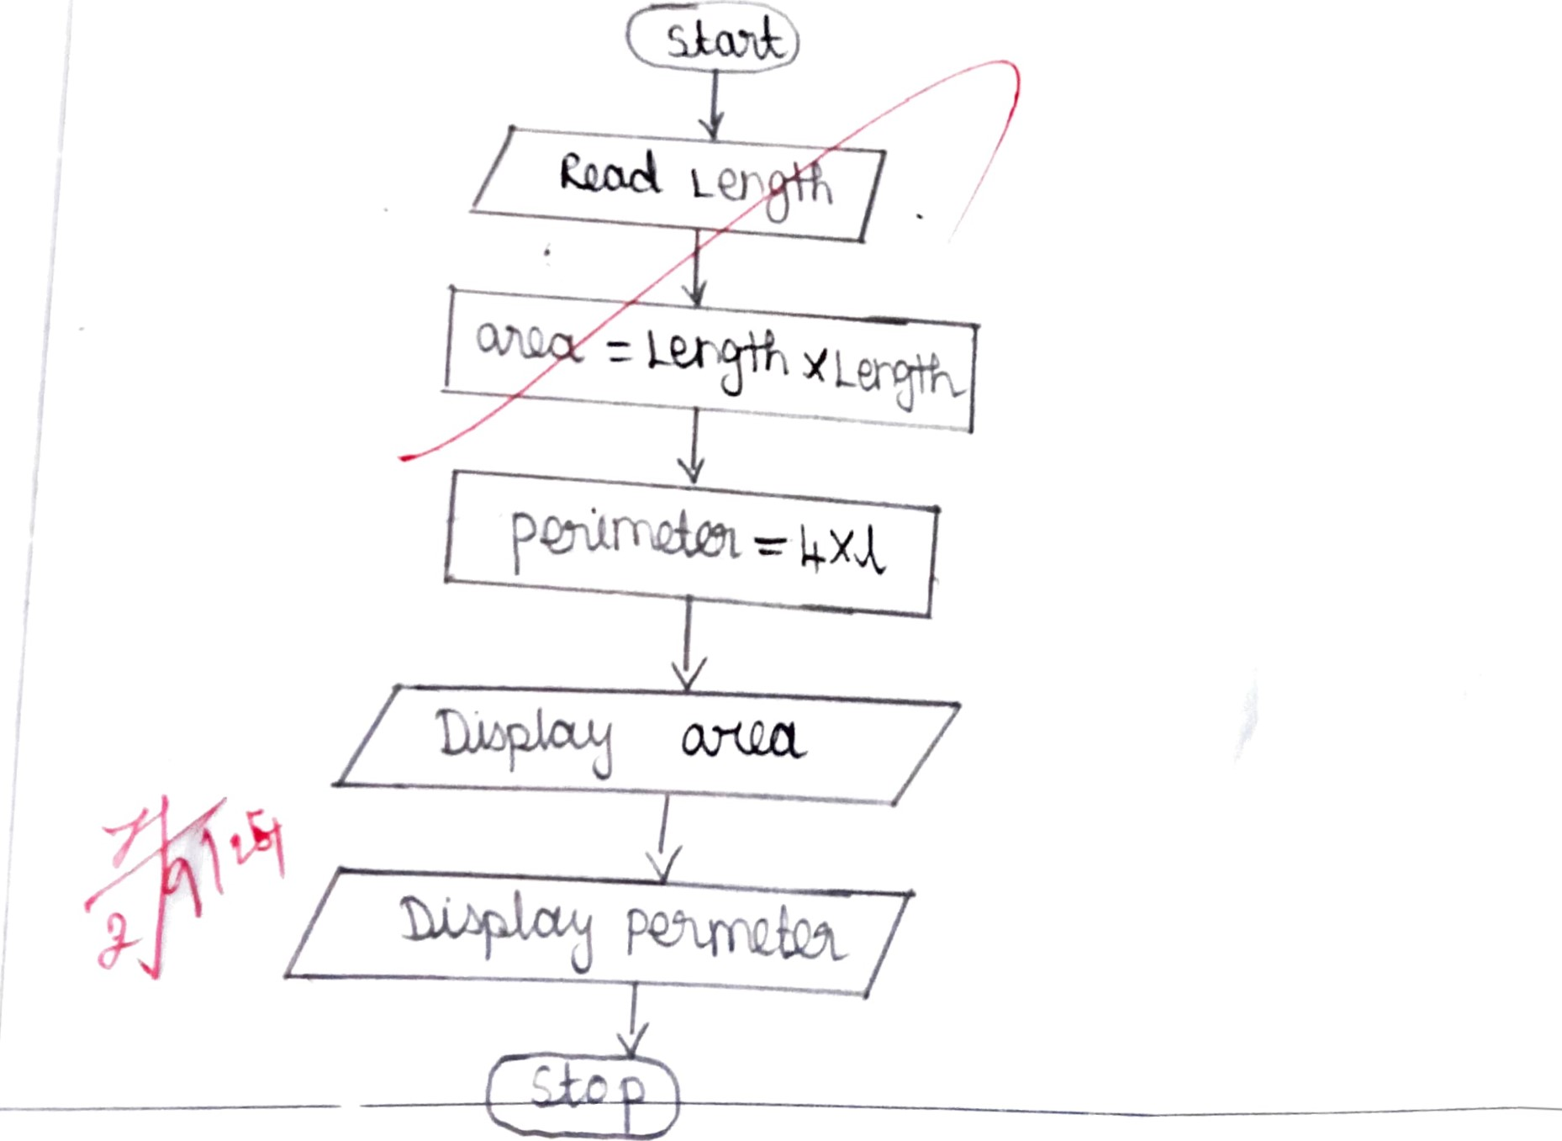Ex No

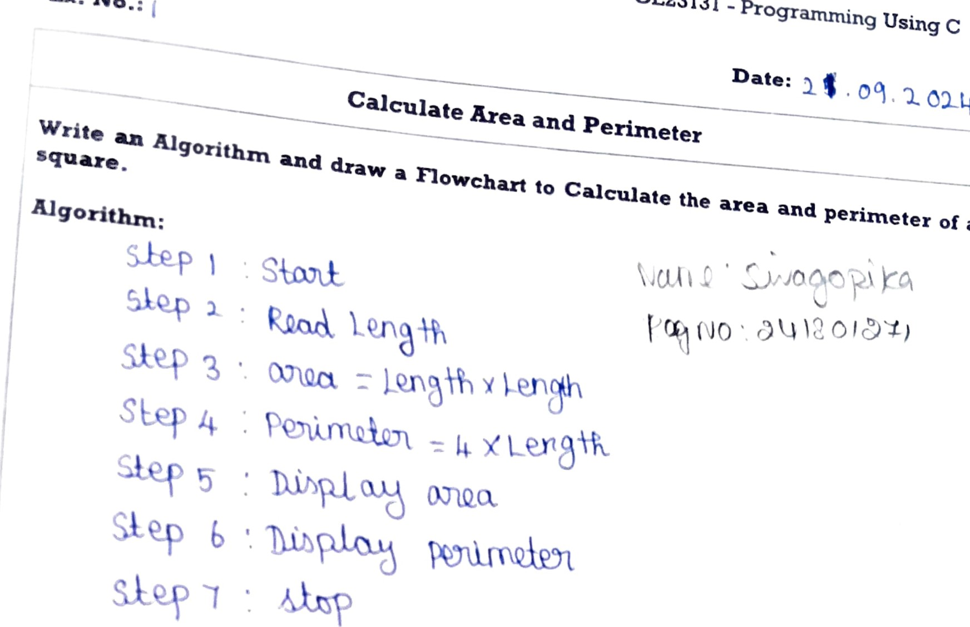

GE23131

Programming

Using

C



College

Science

and

Engineering,

Engineering

Rajalakshmi

Flowchart:

GE23131 - Programming Using C



Science

and

Engineering,

Rajalakshmi

Engineex

Ing

College

Ex. No.. Date:

|  |  |
| --- | --- |
| Days to Year Conversion |  |
| Write an Algorithm and draw a Flowchart to convert the given days into years & months.  Algorithm:  Flowchart: |

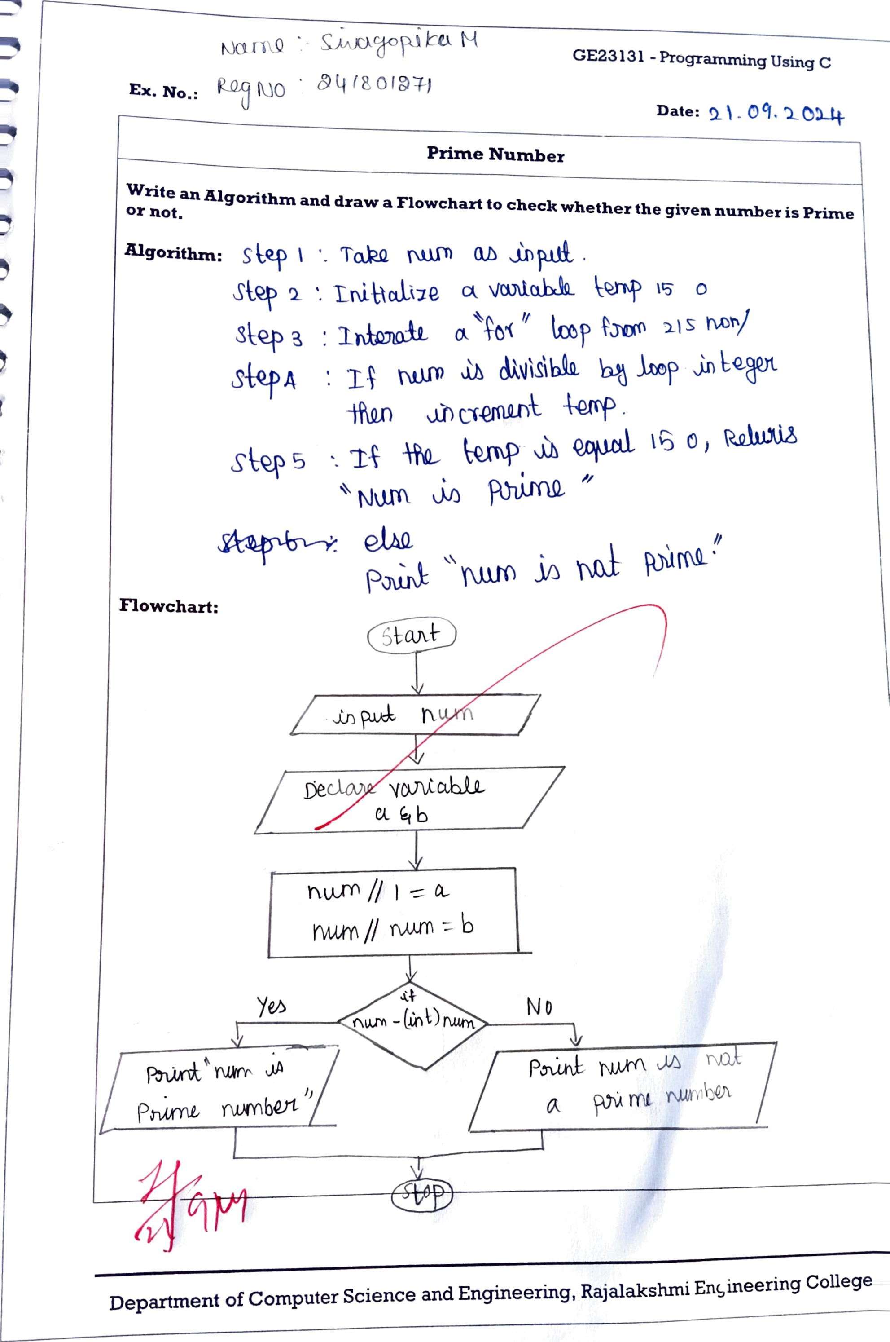

* Using

Ex. No.:

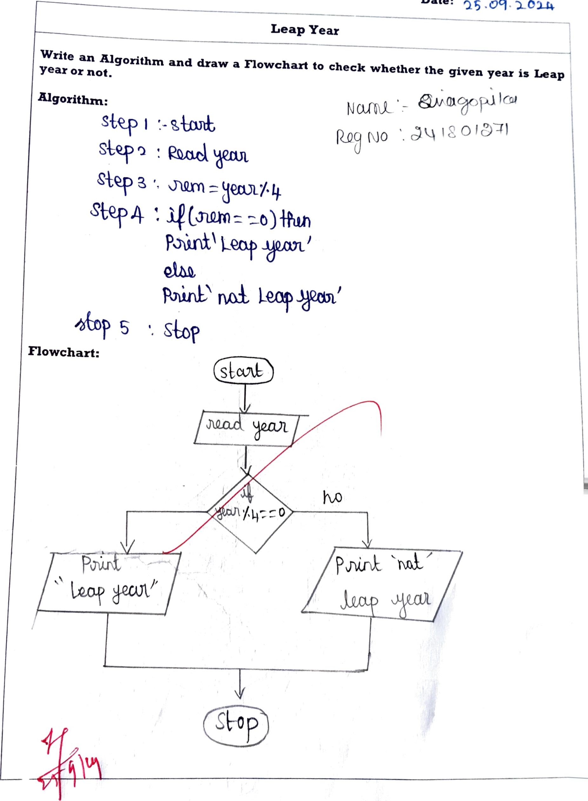

Date:

Science and Engineering, Rajalakshn.i Engineering College

Using



-

Ex. No.: Date

|  |  |  |  |
| --- | --- | --- | --- |
| Palindrome Number    Write an Algorithm and draw a Flowchart to check whether the given number is palindrome number or not.  Algorithm:  00.11 slap b n -n/to avow  o)  Flowchart: | | | |
|  | | nrn |  |
|  |  | | |
| Department of Computer Science and Engineering, Rajalakshmi Engineering College | | | |

* Usmg

Ex. No.: Date: 

|  |  |
| --- | --- |
| Sum of Digits |  |
| Write an Algorithm and draw a Flowchart to calculate the sum of digits in the given number.  Algorithm:  SEQ?L}  ouxmin&bt  to  Flowchart:  [10 |

Department of Computer Science and Engineering, Rajalakshmi Engineering College